**Task 1 A (B)**

**Visual Interface**

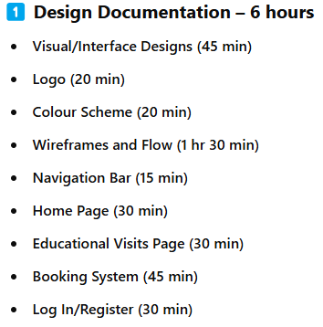

**Wireframes (Low and High fidelity)**

**Main Tip**: You will need to make two types of wireframes, low and high fidelity.

**KEEP THE WIREFRAMES SIMPLE, the simpler you make these, the easier it will be to make your website.**

Low fidelity has the least detail and a lot of placeholders. This can’t have colour. You shouldn’t spend too much time on these, do it as quick as you can.

High fidelity is more specific, a lot of the place holders will be filled in, usually the images are still a placeholder. High fidelity needs to have colour as well. You can spend more time on these, but don’t spend too long.

* Place holders for images is a box with a cross in it.
* Place holders for text is lines

**Examples**:

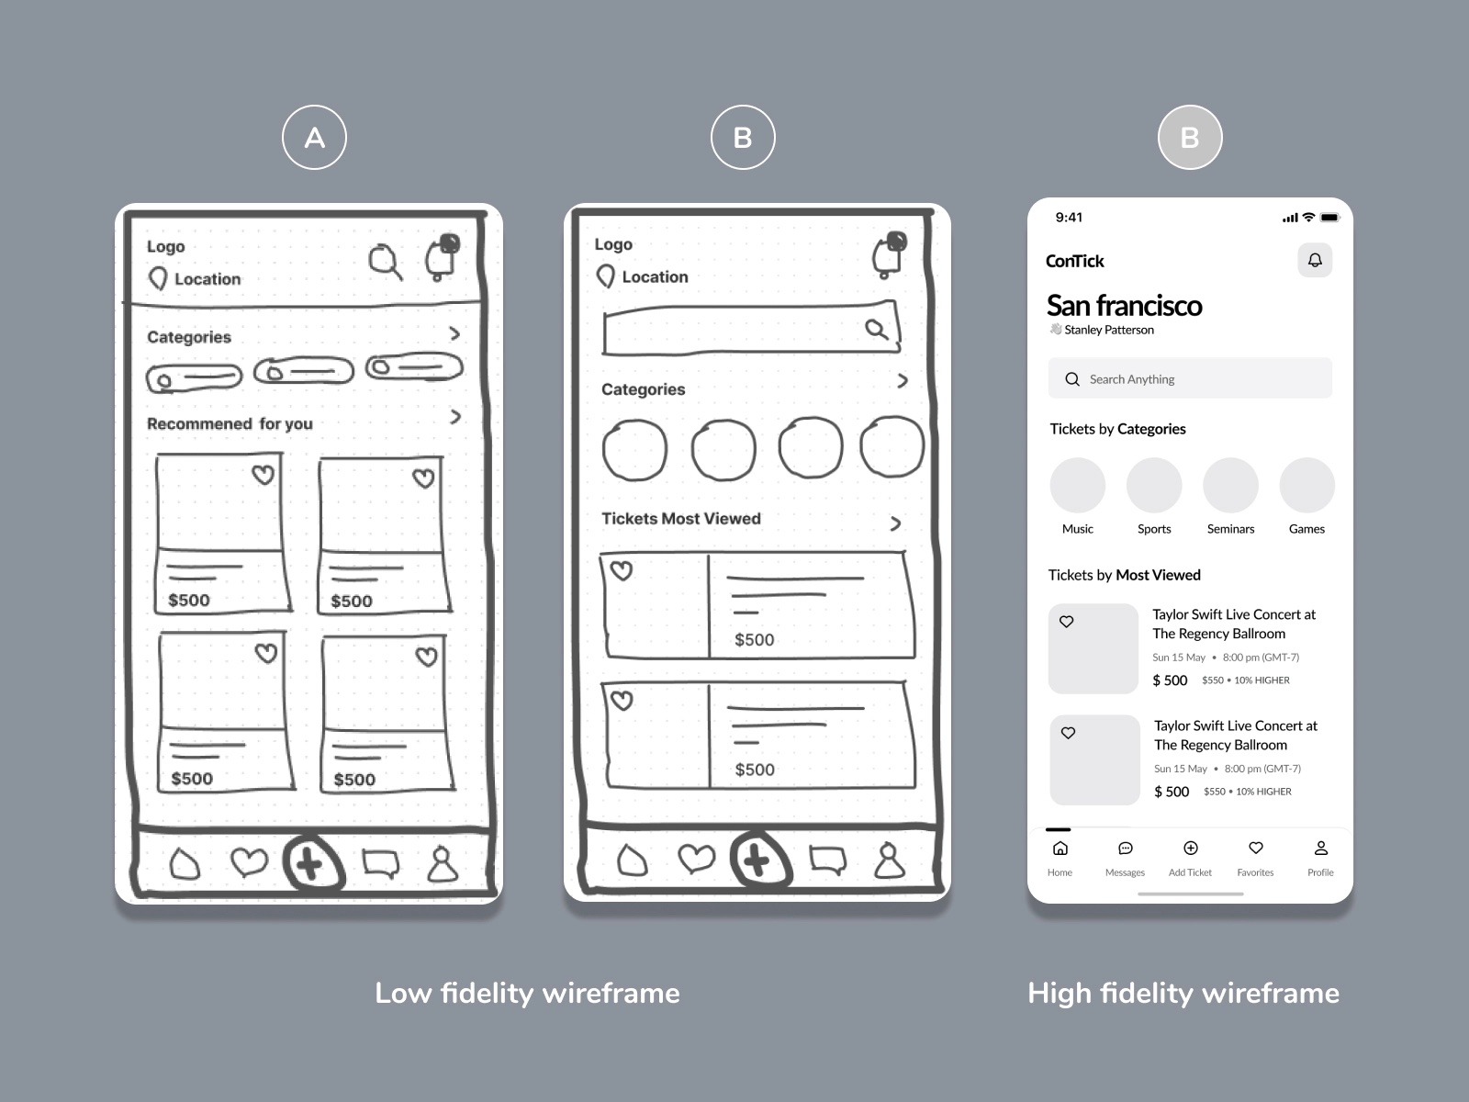

**Sources to use**:

**Examiner reports**:

**Page Specification**

**Main Tip**:

**Examples**:

**Sources to use**:

**Examiner reports**:

**Colours**

**Main Tip**: Use the contrast checker above, primary colours + secondary colours, colour combination, explain why you picked those colours etc.

**Examples**:

**Sources to use**:

**Examiner reports**:

**Sources**

**Main Tip**: Links to sources, to prove the information

**Examples**:

https://www.londonzoo.org/

https://www.chesterzoo.org/

https://www.marwell.org.uk/

**Sources to use**:

**Examiner reports**:

**Site Map**

**Main Tip**: Add a map

**Examples**:

**Sources to use**:

**Examiner reports**:

**Navigation Flow Diagram**

**Main Tip**:

**Examples**:

**Sources to use**:

**Examiner reports**:

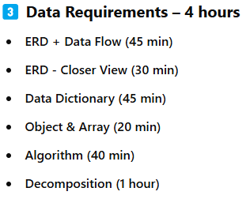

**Data**

**Data Tables/Data Types**

**Main Tip**:

**Examples**:

**Sources to use**:

**Examiner reports**:

**Data Dictionary**

**Main Tip**: Data dictionary to show the informaton

**Examples**: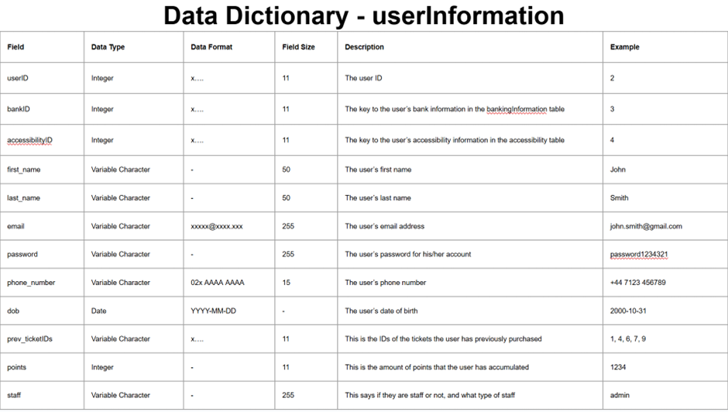

**Sources to use**:

**Examiner reports**:

**ERD Diagram**

**Main Tip**: To show how things work

**Examples**:

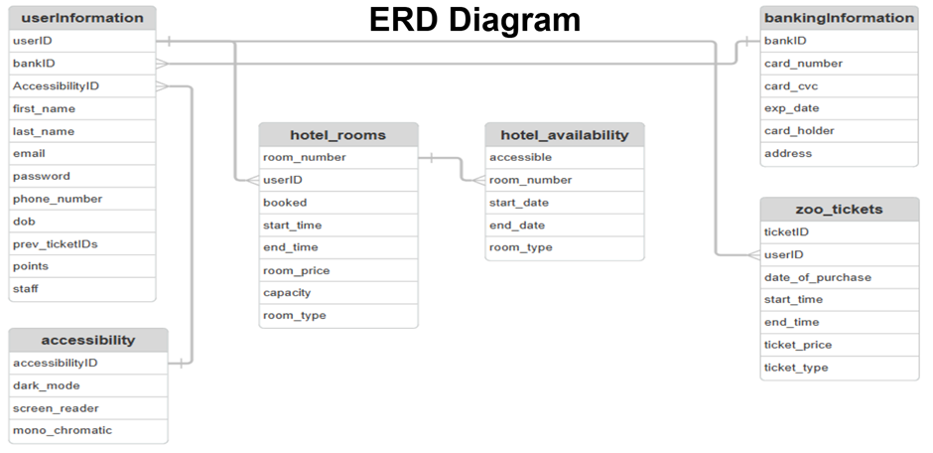

**Sources to use**:

**Examiner reports**:

**Data Flow Diagram**

**Main Tip**:

**Examples**:

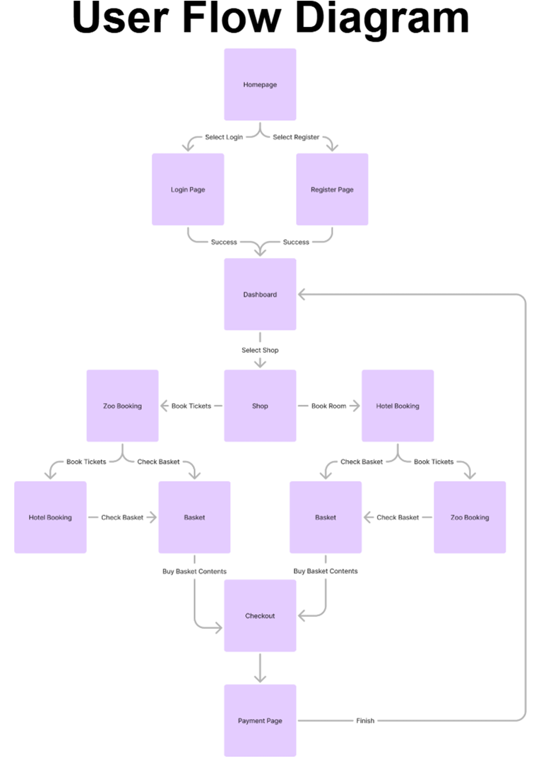

**Sources to use**:

**Examiner reports**:

**Algorithms**

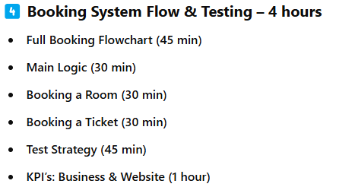

**Flowcharts/Pseudocode/Natural Language**

**Main Tip**: Pick whatever is more appropriate for your code.

This is to decompose you code, you just have to pick a way to decompose it and then put it on your document.

**Examples**:

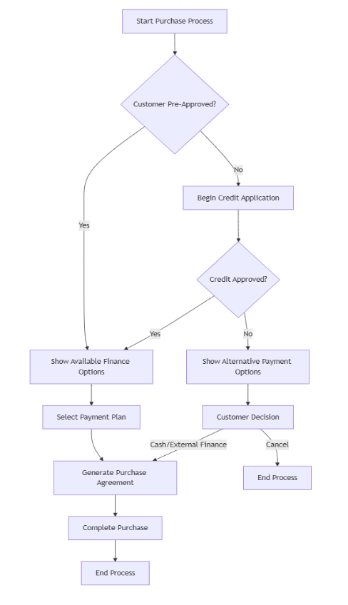

Pseudocode

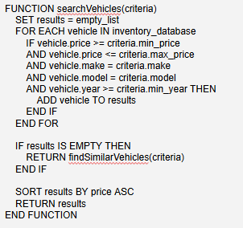

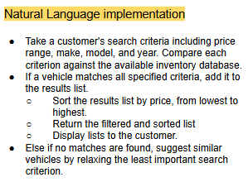

**Sources to use**:

**Examiner reports**:

**Testing**

**Testing Strategy**

**Main Tip**:

**Examples**:

**Sources to use**:

**Examiner reports**:

**Test Plan**

**Main Tip**: Test strategy to show when testing was executed

**Examples**:

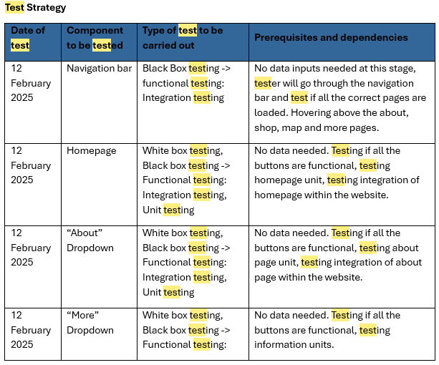

**Sources to use**:

**Examiner reports**:

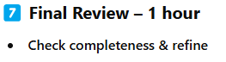

***Examiners Report:***

